PYCTS User Manual

Software Version: 1.0

Andrew Lindsay

Timothy Best

Mark Platek

Spring 2014

Clarkson University

Potsdam, New York

[www.clarkson.edu](http://www.clarkson.edu/)

**Contents**

[1) Preamble](#h.ps1ybljkgkud)

[1.1) About PYCTS](#h.pdhtes8j93mq)

[1.2) About This Document](#h.e3xkjul3xdp0)

[1.3) Implementation Details](#h.m364wj8urzg7)

[1.4) User Levels](#h.qdj9paye4sv9)

[1.5) Acquiring PYCTS](#h.6kf1cbwfjvlk)

[2) Student Guide](#h.cg0vels87wkz)

[2.1) Introduction](#h.bx96qiuvxciw)

[2.2) Logging In](#h.auuazkyjhpw1)

[2.3) Checking Credits](#h.ggovysrv5p6q)

[2.4) Checking Available Studies](#h.cvgwisilccsn)

[3) Research Assistant Guide](#h.h1nel29c9hwo)

[3.1) Introduction](#h.6eoqbr2vi7nw)

[3.2) Logging In](#h.x6itbi3e1upn)

3.3) Adding Credits with Quick-Add

[3.4) Viewing a Single Student’s Data](#h.ci54bio4dc97)

[3.5) Adding Miscellaneous Credits](#h.13jyjww8ay8s)

[3.6) Adding Study Credits](#h.i1lcqgybr91r)

[3.7) Removing Credits](#h.9xx0b2g535fs)

[3.8) Viewing Statistics](#h.ar2yh93ch6c2)

[4) Professor Guide](#h.3o4yul69pee9)

[4.1) Introduction](#h.hir5qvuex760)

[4.2) User Administration](#h.dui57eoffh2x)

[4.3) Study Administration](#h.okmtm98300uj)

4.4) Block Management

[4.5) Roster Management](#h.jimzcnaoeqwj)

4.6) Backing Up the Roster

4.7) Modifying System Options

# 1) Preamble

## 1.1) About PYCTS

The Psychology Credit Tracking System (PYCTS) is web based software designed to allow faculty and *students* to easily track research credits earned by *students* enrolled in Introductory Psychology. *Students* are added to the PYCTS roster in the beginning of each semester. As the semester progresses, *Professors* and *Research Assistants* can add and remove credits for each *student* based on the studies that *student* has participated in, or alternative work. *Students* may log in to PYCTS in order to check the number of credits they have earned.

Dr. Andreas Wilke commissioned PYCTS on behalf of the Clarkson University Psychology department. It was tested in the Evolution and Cognition Lab, under the supervision of Dr. Andreas Wilke. Mark Platek implemented PYCTS, and early UI work was performed with the help of Josh Caprood. The system was then updated and maintained by Andrew Lindsay and Timothy Best. To reach out to the current maintainer(s) of PYCTS contact Dr. Andreas Wilke, his contact information can be found at http://www.clarkson.edu/psychology/.

## 1.2) About This Document

This document corresponds to version 1.0 of the software. It is split into sections for each type of user (*Student*, *Research Assistant*, and *Professor*); each section contains how-to guides for completing various tasks. This document is a thorough and complete guide, covering the operation of PYCTS. New users are advised to use the primer documents which come bundled with the system as they are more concise.

## 1.3) Implementation Details

PYCTS is implemented in PHP, and is intended to be run on a standard LAMP (Linux, Apache, MySQL, PHP) server. An administrative manual exists to provide maintainers with installation and technical instructions. The software has been verified to operate correctly in Firefox 3 and 4, Chromium 8-11, Safari 3.5, and IE 8. It is possible for PYCTS to be used with JavaScript disabled; however, this requires cookies to function correctly. All HTML generated by PYCTS has been verified by the author to conform to the ‘Strict’ W3C XHTML 1.0 specification. Any nonconformity with this specification is a bug and should be reported as such if discovered.

## 1.4) User Levels

PYCTS supports three different types of users: *Students*, *Research Assistants*, and *Professors*. *Student* users are the most limited, and can only view their own research credits and current research credit opportunities. *Research Assistant* users are able to assign credits, and can view information about all *Student* users in the PYCTS roster. *Professor* users have all the capabilities of *Research Assistant* users, plus the ability to perform administrative actions.

## 1.5) Acquiring PYCTS

PYCTS is completely free and open source. PYCTS is licensed under the GNU General Public License and as the source code is available at www.github.com/andlindsay/PYCTS.

# 2) Student Guide

## 2.1) Introduction

Once they have logged in, *Student* users of PYCTS are able to see the credits that they have been given. *Students* can also see upcoming research that they may wish to participate in. *Students* are able to send themselves an email of their credit report, as well as download flyers for upcoming research studies.

## 2.2) Logging In

When a user navigates to PYCTS, they see the following screen.



Figure 1: PYCTS login screen

The *student* may then enter their Clarkson Active Directory username and password to login. This is the same username and password used to access all other Clarkson web services. If the *student* has not been added to the PYCTS roster, they will be notified that this is the case.

## 2.3) Checking Credits

After logging in, the *student* sees the following information.

student_report.png

Figure 2: Student main screen

A table of credit information is shown, indicating what studies the *student* has received credit for and a total number of credits. At the bottom, the *student* may click the button to send themselves an e-mail report of the information shown on this page. The *student* may replace the pre-filled Clarkson e-mail address with another address, and the report will be sent to that address. The *student* may return to this screen at any time by clicking the **Report** tab in the top navigation bar. The *student* may also log out of PYCTS at any time by clicking the **Log Out** button in the top right corner of the navigation bar.

## 2.4) Checking Available Studies

The *student* may view a list of research studies currently in progress by clicking the **Studies** tab. This screen indicates which studies are available by giving an IRB number, a short description, and a link to a downloadable flyer. *Students* are emailed when flyers are added.

# 3) Research Assistant Guide

## 3.1) Introduction

*Research Assistant* users are the most frequent users of PYCTS. *Research Assistants* can add and remove credits, view credits given to any *student*, and see statistics regarding all of the credit information in PYCTS.

## 3.2) Logging In

When a *Research Assistant* first logs in, they see the following screen.

ra_main-screen.png

Figure 3: Research Assistant main screen

The large table below is the roster; a complete listing of all *students* that have been added to PYCTS. The navigation bar features two tabs, **Roster** and **Statistics**. The first returns the user to this main screen, the second shows the **Statistics** page.

The *Research Assistant* can use the **Quick Add** feature (found immediately above the roster) to add credits to any number of *students*.

The roster can be sorted by any field in the table by clicking on the column header for that field. By default, the roster is ordered by *students*’last names. The *Research Assistant* can log out at any time by clicking the **Log Out** button in the upper right of the page header.

## 3.3) Adding Credits with Quick Add

**Quick Add** is a convenient tool for *Research Assistants* that have a lot of credits to add at once. It is located at the top of the **Roster** tab (see Figure 3). To use this feature, the *Research Assistant* must make a selection of *students* to receive credits, using the checkboxes to the far right in the roster table. Then, a study to give credits for is selected in the dropdown box. The amount of credits each study is worth is listed next to the study’s name and IRB number. If it is necessary to give a description about why the credits are being added, the *Research Assistant* can enter one in the box below the dropdown menu. It is not ordinarily necessary to do this.

Clicking the **Add Credits to Selection** button then causes the appropriate number of credits for the selected study to be added to the selected *students*. If the action is successful, then a green notification bar will appear immediately beneath the header. If the action is not successful, the bar will be red and contain an error message.



Figure 4: Notification bar indicating that the action was successful. If the action had failed, the bar would be red and contain an error message.

## 3.4) Viewing a Single Student’s Data

A *Research Assistant* can view the credit data for a single *student* by clicking that *student’s* last name in the roster. This action will display a screen similar to the one shown on the next page in Figure 5.

At the top is the header, giving a summary of the *student’s* information. The **Add Miscellaneous Credits** and **Add Study Credits** forms allow the *Research Assistant* to give credits to the *student*, and the **Remove Credits** section allows the *Research Assistant* to remove credits from the *student*. At the very bottom is a table listing all credits the *student* has received; this table also states the study associated with each credit and the user who assigned the credit.

## 3.5) Adding Miscellaneous Credits

A miscellaneous credit is one that is given to a *student* to increase their credit total, but is not associated with any particular study. It is common for these credits to be given for independent study projects or research papers. Miscellaneous credits can be added from a *student’s* page. To add a miscellaneous credit, the *Research Assistant* must select the number of credits they wish to add, and then enter a description for those credits. The description is required for auditing purposes. When a description has been entered, clicking the **Add Credits** button will add the credits; a notification bar will appear to indicate success or failure of the action (the bar will be green or red respectively). The *Research Assistant* can switch the block to which credits are added. individual.png

Figure 5: Screen showing the data for a single student

## 3.6) Adding Research Study Credits

Adding a study credit through the student page is much the same as doing so through the **Quick Add** functionality on the roster page. The *Research Assistant* selects a study, enters a description if appropriate, and clicks the **Add Study Credit** button. As always, a green or red notification bar will appear to indicate success or failure of the action.

## 3.7) Removing Credits

In PYCTS, credits given cannot be deleted. They can only be removed so that they do not contribute to a *student’s* credit total. Removed credits appear at the bottom of the credit listing, with their fields crossed out (See Figure 5). The fields shown for a removed credit reflect the description left by the user that performed the removal, the user that removed the credit, and the date and time the credit was removed.

To remove a credit, select it using its checkbox on the far right of the credit-listing table. Then, enter a description in the **Remove Credits** text box that indicates why the credit is being removed. Finally, click the **Remove Credits** button and a green or red notification bar will appear to indicate whether or not the action was successful.

## 3.8) Viewing Statistics

It is possible to see statistics regarding credits in PYCTS. To view the statistics page, click on the **Statistics** tab. An example of this page is displayed on the next page, in Figure 6.

The **Statistics** tab gives the following information:

• Total number of *students* in the roster

• Total number of credits that have been given to *students* (removed credits are not counted)

• Average number of credits per *student*

• Average number of credits per *student*, for each *Professor*

• Number of *students* with a specific number of credits

• Per-study statistics; amount of credit assignments and total value of these assignments

The total number of credits reported might not match the sum of all credits assigned to studies; miscellaneous credits will be factored into the former statistic.

stats.png

Figure 6: Statistics page showing aggregate statistics for all students in the roster

# 4) Professor Guide

## 4.1) Introduction

*Professor* users are capable of performing all tasks that a *Research Assistant* user is capable of performing. The reader is advised to begin by reading the *Research Assistant* Guide (see Section 3). *Professors* also have a greater level of administrative access to PYCTS. They are responsible for adding and removing system users (*Research Assistants* or other *Professors*), maintaining the list of available studies, adding and removing *students* from the roster, and making backups.

## 4.2) User Administration

A *Professor* has access to the **Users** tab. It includes the ability to add and delete users from PYCTS, and the ability to remove *students* from the roster. The **Users** tab is pictured below in Figure 7.users.png

Figure 7: The Admin Panel; most frequently used for user administration

At the top of the **Users** tab, there is a table listing all PYCTS users. Beneath that, there are forms for adding and removing users, followed by a form for removing *students* from the roster.

To add a user, fill out all fields (first and last name, Active Directory username) and select a Role and Professor (if adding a *student*). Be aware that *Professor* users are able to execute acts which can damage the roster, so choose the user level wisely.

To delete a user, select that user from the dropdown menu and click the **Delete User** button. Unlike credits, deleted users disappear from the user list entirely and cannot be recovered. Be careful to choose the correct user when performing deletions. PYCTS does not allow the last *Professor* user to be deleted, nor does it allow a user to delete themself.

To delete a *student* from the roster, simply enter the Active Directory username and click the button. All credits associated with that *student* are deleted when the *student* is deleted - the credits are not recoverable if the *student* is later added back into the roster. Since the roster is likely to change completely between semesters, PYCTS enables a *Professor* to completely wipe it, deleting all *students* and credits. Studies and PYCTS users are not affected by a database wipe. To invoke a database wipe, type the word "confirm" into the text box and click the button.

**A database wipe permanently deletes all *students* in the roster, as well as all credits present in the database. Be sure that this is what you want to do before you invoke a database wipe.**

## 4.3) Study Administration

*Professor* users are also responsible for maintaining the list of studies available to *students*. The study administration panel is similar to the example given below.

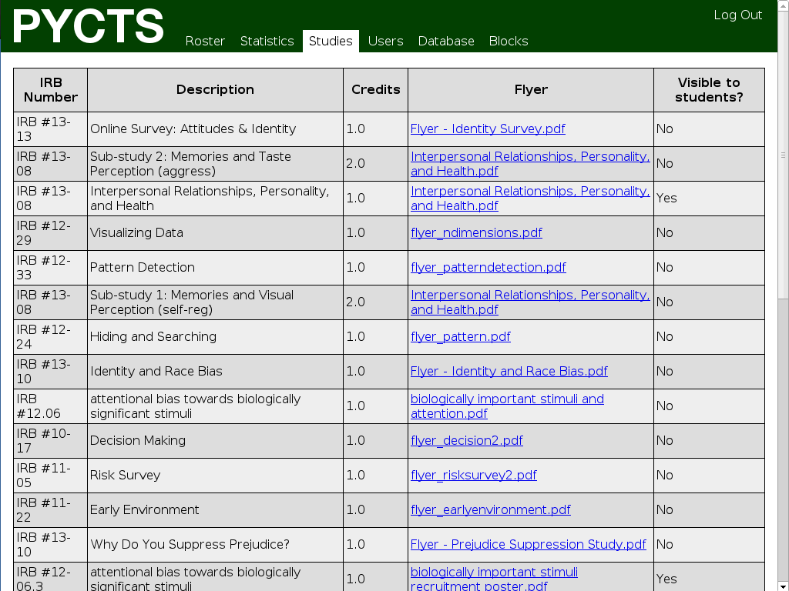

Figure 8: List of available studies

At the top of the **Studies** tab, there is a full list of all studies present in PYCTS. Each study is required to have the following elements: an IRB number, a short description or title, and a flyer. Each study is worth some number of credits, and the user is given the opportunity to control whether or not *students* are able to view the study.

The study panel provides forms for adding and deleting studies, as well as for editing the information for existing studies. There is a separate form for changing the visibility of a single study.

To add a study, first enter its IRB number. The IRB number should just be the numbers (e.g. 11-19 or 10-21) and not any extra characters. Then, select the number of credits the study is worth - studies worth more than 10 credits are unsupported. Then, choose a file to upload as the study's flyer. Only PDF files are accepted, if your flyer is in any other format, you will need to convert it. Most office software (including LibreOffice and Microsoft Word) is capable of performing this conversion. Finally, enter a description for the study. It is best if this description is the title of the study; this will help *students*, who are looking at the studies, find one that they wish to participate in.

To delete a study, simply select it from the dropdown menu and click the **Delete Study** button. Be aware that it is not possible to delete a study once it has had credits assigned for it. The best time to remove old studies is when the database is wiped, at the beginning of the semester.

If a study is no longer accepting participants, but cannot be deleted due to credits being assigned for it, the study should be made invisible to *students* so that nobody attempts to sign up for it. A study's visibility status can be toggled between "visible" and "not visible" by selecting that study and clicking the **Toggle Visibility** button.

If a study's information needs to be changed after the study is created, it is possible to make modifications. Select a study from the dropdown in the **Edit Study Info** form, and then enter any new information into the appropriate field(s). If you do not wish to change a particular aspect of the study, leave its field blank.

## 4.4) Block Management

PYCTS is designed to work based on a block system which divides the semester into a set amount of time periods. This is intended to stop students from front or back loading their research credit requirements so that all studies get an equal amount of participants. To set the amount of blocks which PYCTS will use, a roster must be uploaded and at that time the blocks can be modified. This feature is only available so long as no credits have been assigned in the system. After uploading a roster and setting the amount of blocks in the system, the start date of each block may be modified in the system options tab. Please see section 4.5 for more information on roster upload.

**Note: PYCTS can handle a theoretically infinite amount of blocks, but good performance and aesthetics can only be guaranteed up to five blocks.**

## 4.5) Roster Management

Only *Professor* users are able to add new *students* to the roster. *Students* can be added one at a time, or in bulk in the form of a CSV file of *student* information. The roster management screen is shown below in Figure 9.

To put a *student* into the roster manually, enter their information in the appropriate text boxes. To ensure consistency of the roster, be sure to check for typing errors. The alternative option is to create a CSV file of *student* information, then upload it to PYCTS.

PYCTS will then parse the CSV and add *students* based on the information it contains. CSV files must be formatted a certain way in order for PYCTS to understand them properly. The instructions for creating a well-formatted CSV are below and included in the roster management screen.

Figure 9: Student information can be entered manually or in bulk using a CSV file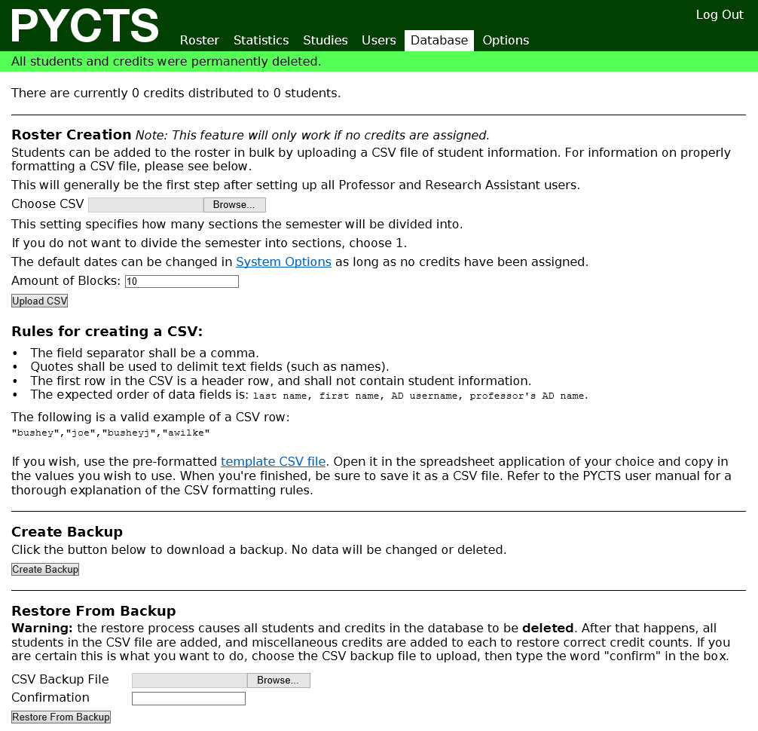

The field separator is a comma. Quotes shall be used to delimit text fields (such as names). The first row in the CSV is a "header" row, and shall not contain *student* information. The expected order of data fields is: last name, first name, AD username, Professor's AD name.

Please see the examples below (Figures 10 and 11) for a more clear idea of what the CSV file should look like.

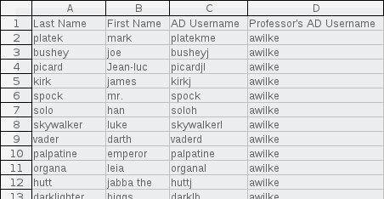

Figure 10: A CSV file viewed in LibreOffice Calc

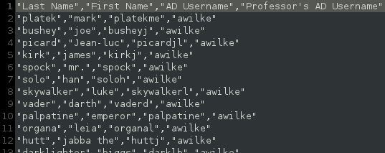

Figure 11: The same CSV viewed in plain text form

For your convenience, a template CSV file exists with a header row in place already. This template can be downloaded from a link on the roster management screen. PYCTS has been demonstrated to work correctly with CSV files generated by LibreOffice (on any platform) and by Microsoft Excel (on Windows). Mac users using Microsoft Excel must export the spreadsheet in the "Windows CSV" format.

When a CSV is uploaded, it is not possible to thoroughly verify that the CSV is formatted correctly. Take care to ensure that the CSV meets the specification before attempting to upload it. If any *students* fail to be added correctly from CSV data, their information as well as an error message will appear in the notification bar that appears after the upload action is complete. It is recommended that any error messages be copied down.

## 4.6) Backing Up the Roster

*Professor* users are able to make a backup of the current roster and restore from it at a later date. Refer to Figure 9 to see the **Database** tab. It is important to note that the backup is not complete; it only preserves correct credit counts for the *students* in the roster. It does not keep track of which *students* have completed which studies. The backup takes the form of a CSV file. To create a backup, just click the button. The CSV will be generated, and a link to download it will appear in the notification bar. To restore the roster from a backup in the Database Tab, select a CSV file to upload, enter the word "confirm" in the text box, and click the button. Any errors encountered while restoring from the backup will be printed in the notification bar - it is recommended that they be copied down at this point.

**Note: Restoring from a backup wipes the current roster and all credits before attempting to restore from the information in the file. All restored credits will be marked as miscellaneous.**

## 4.7) Modifying System Options

The final tab in PYCTS is the **Options** tab. This tab is only visible to *Professor* level users and contains fields allowing for the modification of block dates and the text of email notifications.

To modify the dates on which blocks start, fill in all fields in the **Modify Blocks** form and click the **Modify Blocks** button at the bottom of the form. The values input for each block must be a date after the previous entry, and the fields use the American date format of MM/DD/YY.

**Note: Block dates can only be changed if there are no credits in the system, as such, this should be set up at the beginning of the semester.**

To modify the text, which is sent along with the automated notification emails that the system sends out, edit any one of the text fields on the second section of **Options** tab and click the corresponding **Update text** button. To generate a test email, which will be sent to the current logged in user, select the message type from the **Test Email** dropdown at the bottom of the page and click the button to send the email.

**Note: HTML tags are supported in these fields, but it is recommended their usage be avoided since it is impossible to guarantee the technical experience of all users.**

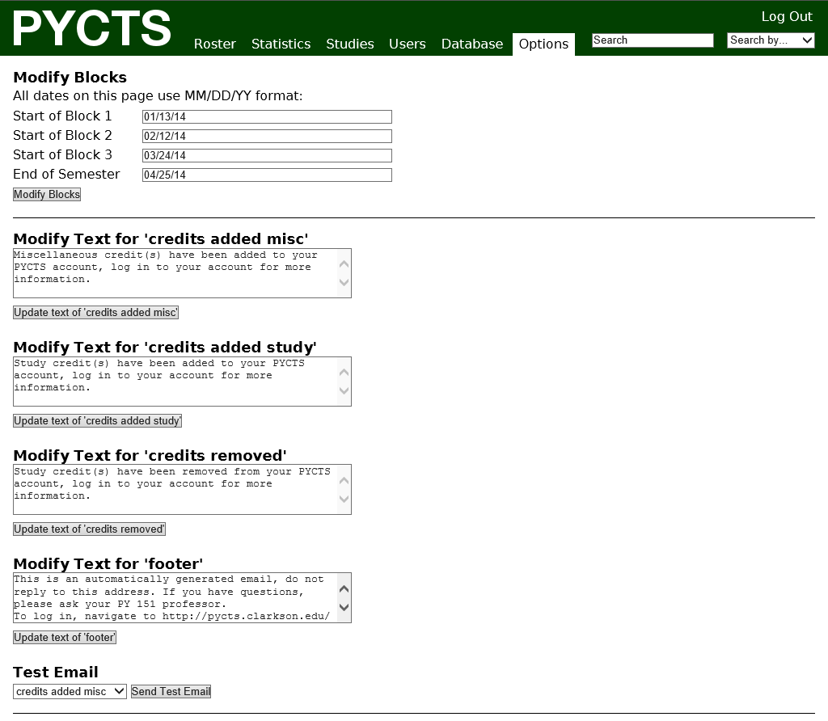

Figure 12: PYCTS’ options tab.